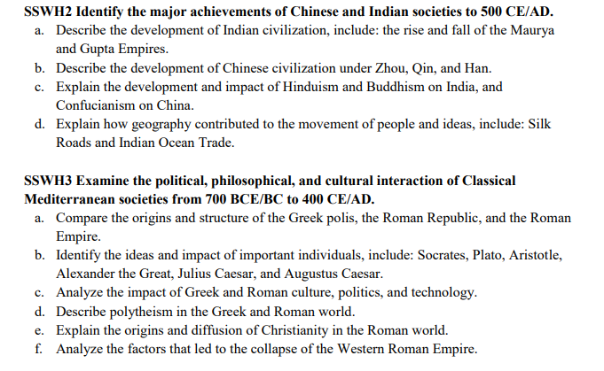

**KEY TERMS**

**Hinduism**

**reincarnation**

**karma**

**dharma**

**moral law**

**Four Noble Truths**

**Asoka**

**Shang Dynasty**

**Zhou Dynasty**

**Qin Dynasty**

**Great Wall**

**Han Dynasty**

**Silk Road**

**Mandate of Heaven**

**Confucianism**

**Daoism**

**Legalism**

**Marco Polo**

**Travel narrative**

**Oligarchy**

**Thucydides**

**direct democracy**

**Thermopylae**

**Socrates**

**Peloponnesian War**

**Pheidippides**

**Acropolis**

**Thermopylae**

**Minoans**

**Minoan decline**

**Hellenistic Era**

**Persian wars**

**Parthenon**

**Pericles**

**Etruscans**

**Republic**

**First Triumvirate**

**Julius Caesar**

**Diocletian**

**Theodosius**

**Tiber river**

**Diaspora**

**Caesar Augustus**

**Hannibal’s Army**

**Pax Romana**

**Romance languages**

**Aqueducts**

**Nero**

**Visigoths**