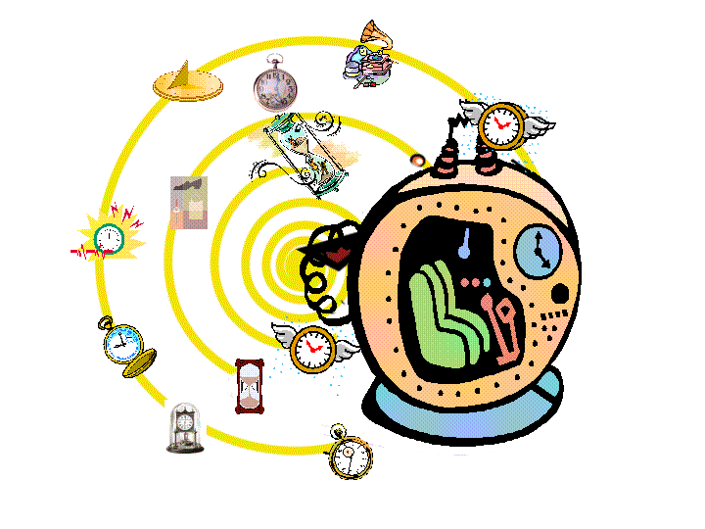

After years of research, you have finally managed to create a time machine!
Unfortunately, you can’t really control it.
On your first test run, you set it to travel only 130 minutes into the past.
After a few minutes of whirring noises, your machine comes to a stop, and you step out, and it’s not quite what you expected…
Your eyes have trouble focusing at first, but when they do, you realize the massive structure is definitely NOT from the 21st Century
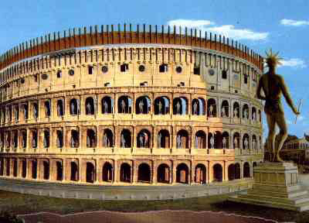
Before you fully comprehend the mistake you’ve made, two men dressed in bronze armor seize you by the arms and take you to a marble villa. Inside, there are hundreds of people dressed in white robes with red sashes.
In the center of the room is a large throne. The man sitting on it is more richly dressed in silks than those around him. He is middle aged and muscular with a closely cropped curly beard. One of the guards goes over to him and whispers something into his ear. The man’s eye widen with shock. He summons for a piece of parchment and pen, and spends several minutes in silence writing. He rolls up the scroll and gives it to a servant. Only then does he begin to speak aloud, and you are secretly are grateful for your high school Latin.

"I, Caesar Hadrian proclaim you a servant of the Emperor. You, stranger, have come to Rome with your unusual machine. I see from your clothing that you must be a foreigner and are perhaps sent by the gods. I have a task for you.”

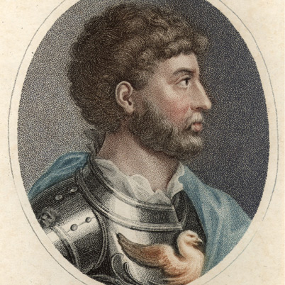
With a motion of Hadrian’s hand, the young servant rushes forward and hands you a scroll containing the task that Hadrian is setting to you. You unroll it to find the document below (translated now into English):

For the Glory of Rome
You are to create a document which shall proclaim to all future generations of the glory of Rome.
Explore the Eternal City of Rome and speak to our people that you might collect the information in this scroll. Then, you are to compile this information in a way in which the achievements of this great empire shall be known to all people.
You shall need your brains and your technology granted by the gods in order for you to complete this task.

By order of Caesar Publius Aelius Traianus Hadrianu
130 AD
Name # Class Period Date

First you are to explore the city of Rome through this virtual tour. Write down 10 sites that you see. Choose two of the sites and look up why they are, who built them, and what their purpose was.

Site 1:

Site 2:
Founding of Rome
Watch the video to answer the questions
- According to myth, who were Romulus and Remus & how were they raised?

- What did they go on to do as adults?

Roman Kingdom
- What date is often given for the founding of Rome and along what river was it founded?

- What neighboring people did the Romans imitate?

- What does Imperium mean? How is it related to the Roman family structure?

- Who ruled alongside the Roman King? What was their function?

- Describe the differences in the Patricians and Plebeians.

Last King of Rome
- What was the name of Rome’s last king? How did he lose power?

- What was established in the place of a kingdom?

- What were the Twelve Tables?

- What did the laws cover?

- Read the 8 examples of laws, which is your favorite and why?

Battlefield Academy:
- Pick the Roman Icon and launch the battlefield game. What happened? How did your troops do?

First Punic War
- What country was Rome fighting & what territory did they control?

- What reason did Rome give for attacking? What was the more likely reason?

- What did Rome need in order to defeat their enemy?

- Who won the first Punic War? What did the winner gain and the loser lose?

Second Punic War
- What was Hannibal’s promise to his men?

- What animal did Hannibal use to cross the Alps?

- What Roman general was called on as Hannibal’s match?

- Who won the war at Zama? What happened to Hannibal after the war?

- In 146 BC, what did Rome do to Carthage? What was the effect on Rome?

Structure of Government Under the Republic
Consuls: Head of Government | Senate ( members) | Assembly
year term | term
Consuls chose the |  | the 2
the army | Directed , including tax dollars
Acted as | Approved or disapproved made by the Assembly | on laws suggested by government officials
In an emergency, consuls could choose a | Made decisions concerning relationships with | Declared
Both consuls had to on their decisions. Each had the power to the other.

Julius Caesar
Use the links to fill in the timeline of Julius Caesar’s life. Answer in SHORT phrases

100 BC
61 BC
58 BC
46 BC
Feb 44 BC
59 BC
72 BC
March 15 44 BC

49 BC

The death of Julius Caesar marks the end of the Roman . His nephew became Rome’s first .

The Roman Empire in the 1st Century

Emperor | Describe the Situations you encountered | Result of your choices  (Were you a good emperor?)
Augustus
Claudius
Nero

Hadrian’s Wall
- Where Hadrian’s Wall built and what was its purpose?

- How was the wall built?

The Pantheon
- Which god was this temple dedicated to? (Hint, this is sort of a trick question)

- How did Hadrian influence the building of the Pantheon?

- What is unique about the Pantheon’s dome?

- What is the significance of the Pantheon?

Roman Aqueducts
- Why did Romans build aqueducts? Why not just get water from their rivers?

- Why were the aqueducts a challenge to build?

- Go to page to two. Where did they build the aqueducts?

Roman Roads
- List two reasons WHY the Romans built roads.

- Who did the Romans get to build their roads?

More on Roman Roads
- Why do they say “all roads lead to Rome?”

- List THREE characteristics of Roman roads.

- Click here. How many miles of road did the Romans build?

- According to the video, what is most distinctive feature of Roman roads?

The Roman Coliseum
- What emperor built the coliseum?

- What was the ancient name of the coliseum?

- The coliseum was built for entertainment? What kind of entertainment did the city show in the coliseum?

Death in Rome:
- Launch the mystery game. Who did it? Did you finish in the allotted time period? Was your guess correct?

Gladiators
- Play the Gladiator game. Did your gladiators win? Briefly describe the different kinds of gladiators

Once you have completed your research, compile the information in a way to present it to Caesar Hadrian. This could be in a PowerPoint, a Prezi, a Glogster, a poster, etc (we’re assuming your time machine has a wi-fi hotspot and presentation materials).

